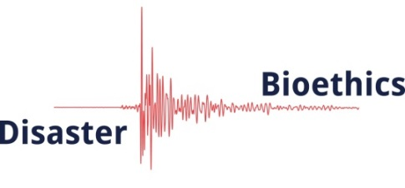

Application for a Place in the Training School for COST Action IS1201: Disaster Bioethics
To be held in Dubrovnik, Croatia on 23-27 June 2014
Italicised notes in the boxes below are for guidance only and should be deleted before submission.
COST Training Schools typically aim to benefit research students, Early Stage Researchers (ESRs), or equivalent practitioners early in their careers. Applicants are welcome to apply if they are researchers in a relevant field, have experience as disaster responders, or are engaged in bioethics.
COST expects a reasonable balance of represented countries among the trainees selected.
Only applications made on this form will be accepted.
The deadline for applications is Friday 9th May 2014 at 17.00 CET

- Name

- Gender

- Relevant degrees, credentials, qualifications (no more than 50 words).

- Are you an Early Stage Researcher or equivalent?
COST definition: currently a research student (not yet obtained a PhD) or obtained a PhD (or equivalent terminal degree) no more than 8 years before joining this Action.

- Current position and Institution
Trainees receiving COST funding must be based at an institution in a COST country that has joined Action IS1201 (see http://www.cost.eu/domains_actions/isch/Actions/IS1201), an approved Near Neighbour Country, or from an approved Research and Technological Development organisation (details at http://www.cost.eu/participate).

- Describe previous or on-going experience, work or research related to Disaster Bioethics (no more than 200 words).
Include here if you are a member of Action IS1201 and how you have been involved already.

- Describe how participating in this Training School will further your research or practice (no more than 200 words).

- Describe a project or publication that you will develop while at the Training School (no more than 200 words)
During the Training School, trainees will be expected to develop a research project or publication proposal which they will complete after the School. During the School, time will be provided to allow trainees to meet 1-on-1 with trainers to develop their proposals, and a presentation on these will be given at the end of the School. Collaboration with other trainees and trainers, and others at home institutions, will be encouraged and should continue after the School to ensure timely completion of the projects and delivery of related outputs.

- Details of funding requested – total cannot exceed €1500
The maximum daily reimbursement set by COST is €160. The Training School is 5 days long = €800. The maximum travel allowance is €300. The standard reimbursement for each trainee will be no more than €1100. However, depending on where the trainee’s home institution is located, some additional funding may be requested. Applicants should state here what funding they require. Total funding in excess of €1500 will not be granted.
Standard accommodation and meal allowance (up to €800):
Anticipated travel costs (up to a maximum of €300):
Special request for additional funds with detailed explanation:

- Email and telephone contacts for the person making the application
email:
telephone:

- The application must be accompanied by a 1-page CV.

- Also required is a letter or email from the applicant’s supervisor or manager (indicating the nature of their relationship) in support of the application, including a statement that the applicant will be available to attend June 23-28 if successful in this application.

If this application is successful, COST and Action IS1201 must be clearly acknowledged in all outputs arising from the Training School.

Please email your completed application (including the CV and letter of support) to Disasterbioethics@dcu.ie and include in the Subject line: Training School application.

